Word download:
http://www.jensen-media.de/download/schneider/triple.docx

Triple triumph for Schneider Kunststofftechnik
The family-owned company has received three awards: the German Innovation Award, German Brand Award and TOP 100

Kirchheim (jm).
Three in one go: following the German Innovation Award and the German Brand Award, Schneider Kunststofftechnik has now carried off its third success. Based in Kirchheim, the family-owned business is again ranked in the TOP 100 German SMEs, and was singled out by mentor Ranga Yogeshwar for its excellent climate of innovation. It is the third time in a row that the plastics specialist has made it into innovation's elite tier.

"The fact that we have managed to bring home three fantastic awards within such a short time is really tremendous", said a delighted Drita Schneider, Managing Director at Schneider Kunststofftechnik GmbH. "The prizes are both a reward and a motivation. Only someone with innovative ideas is able to assert themselves long-term – and new ideas are something you can only get from dialogue with other creative thinkers. That's why we give massive thanks here to our whole team, which works away day after day on new ideas and solutions, thereby contributing decisively to our success." Schneider Kunststofftechnik GmbH manufactures technical plastic parts for customers in the automotive, mechanical engineering, packaging systems and sensor technology sectors and in the mobile security sector. It also offers smart new consumer products.

But the 24-strong team around Drita Schneider is also using its own unique ideas to shape the plastic material it works with. Thanks to its wealth of invention, Schneider Kunststofftechnik ranks amongst the most innovative companies in the German SME sector. TOP 100 mentor and science journalist Ranga Yogeshwar accordingly found himself presenting the TOP 100 seal to the plastics specialists from the Allgäu region for the third time in a row.

The excellent climate of innovation at Schneider Kunststofftechnik, in particular, won over the independent jury judging the competition. That is because "innovation" is writ large at the company's head office in Kirchheim: the management tier invests more than 80 per cent of its working time in the development of innovations. In doing so, Drita Schneider also draws on the wealth of ideas coming from her employees. Suggested improvements are addressed immediately and, on average, three quarters of the suggestions are realised.

The Kirchheim-based plastics specialist also came up with a winning combination for the German Innovation Award, presented for the first time in 2018, via a particularly inventive innovation. Schneider Kunststofftechnik, as the parent company of Ujeta GmbH, received the "Gold" award in the "Business to Consumer" category for its unique "Ujeta Care" water filter system. Ujeta Care is helping ensure that people around the world can obtain clean drinking water for themselves, quickly and easily. Ten of these little helpers from the Allgäu region are in use in Haiti, where they provide around 3,000 children daily with fresh drinking water.

In addition to the two innovation awards, Schneider Kunststofftechnik also carried off the German Brand Award 2018. In the flagship category of "Excellence in Branding", the specialists from Kirchheim secured the "Brand Innovation of the Year" prize. The driving force behind the prize is the German Design Council (Rat für Formgebung), and it is sponsored by the German Brand Institute.

About the TOP 100 Competition:
Since 1993, compamedia has been awarding the TOP 100 Seal for special strength of innovation and above-average success in innovation amongst SMEs. Since 2002, the scientific lead for this has been Prof. Dr. Nikolaus Franke. Prof. Franke is the founder and chairman of the Institute for Entrepreneurship and Innovation at the Vienna University of Economics and Business. The TOP 100 mentor is the science journalist Ranga Yogeshwar. The Fraunhofer Society for the Promotion of Applied Research (Fraunhofer-Gesellschaft zur Förderung der angewandten Forschung) and the German Association for Small and Medium-sized Businesses (BVMW, Bundesverband mittelständische Wirtschaft) are project partners. Media partners manager magazin, impulse and W&V support this company competition. For more information, visit www.top100.de.

About the German Innovation Award:
The German Innovation Award was presented for the first time in 2018, and is being sponsored by the German Design Council (Rat für Formgebung). The new innovation prize is an award for products and solutions across all sectors that stand out primarily for being user-centred and for value-added compared with earlier solutions.
The procedure for the German Innovation Award is unique: only companies nominated by the expert committees and scouts for the German Design Council are able to take part. The German Design Council was set up by the German Bundestag (the lower house of parliament), and as an independent and internationally-operating institution it is committed to promoting the competitiveness of companies. Since 1953, the competitions run by the German Design Council have given awards for achievements of international standing in design, branding and innovation.

About the German Brand Award
Initiated by the German Design Council and judged by a high-calibre panel of experts from brand marketing and brand science, the German Brand Award is an award for successful brand management in Germany. It identifies, showcases and awards prizes for unique brands and brand-makers – and not only helps the winners in moving forward, but also their respective sectors.

About Schneider Kunststofftechnik GmbH:
"Innovation" is the absolute buzzword at Schneider Kunststofftechnik GmbH. That is already demonstrated by the company motto HYPERFORM, which combines two essential elements of the company: extensive experience and innovative, flexible applications for the plastic material. In addition to product manufacturing for customers, Schneider Kunststofftechnik also produces and assembles its own products. This ability to innovate is therefore open to all customers: from technical consultancy to development of own plastic parts to tool and mould-making
Schneider Kunststofftechnik guarantees flexible production of the highest quality. To that end, the Allgäu-based family company recently expanded and modernised its production - thereby also creating new jobs. Its modern fleet of machinery includes two fully-electric injection moulding machines and two fully-automatic production cells with intelligent robot engineering.

All products are manufactured exclusively at the company's head office in Kirchheim (in the Allgäu region). That ensures high-quality "Made in Germany" products, with a guarantee of best manufacturing quality, and also secures jobs in the region.

The family-run business is successfully DIN EN ISO 9001-, DIN EN ISO 14001- and DIN ISO 50001-certified, and is an active participant in "Umweltpaket Bayern", an agreement between the Bavarian state government and Bavarian business for cooperative environmental protection.

Further information:
Schneider Kunststofftechnik GmbH
Hasberger Str. 9c, 87757 Kirchheim, Germany
Tel.: +49 (0) 8266 8 61 20
Fax: +49 (0) 8266 / 861215
email: verkauf@sk-tech.de

Press contact:
Jensen media GmbH, Redaktion, Hemmerlstrasse 4, 87700 Memmingen, Germany Tel.: + 49 (0)8331/99188-0 Fax + 49 (0)8331/99188-80, info@jensen-media.de, Internet: http://www.jensen-media.de
Contact: Ingo Jensen (ingo.jensen@jensen-media.de)

Caption:

top_100.jpg
Delighted by the award (left to right): Production Manager Josef Saule, Anita Geiger (Logistics), Yvonne Ungerer (Purchasing and Sales), Ljubica Mihic (Sales), Elfi Mladenovic (Quality Management), Managing Director Drita Schneider and Operations Manager Reinhard Fendt with TOP 100 mentor Ranga Yageshwar (centre). Photo: KD Busch/ compamedia

Photo materials:
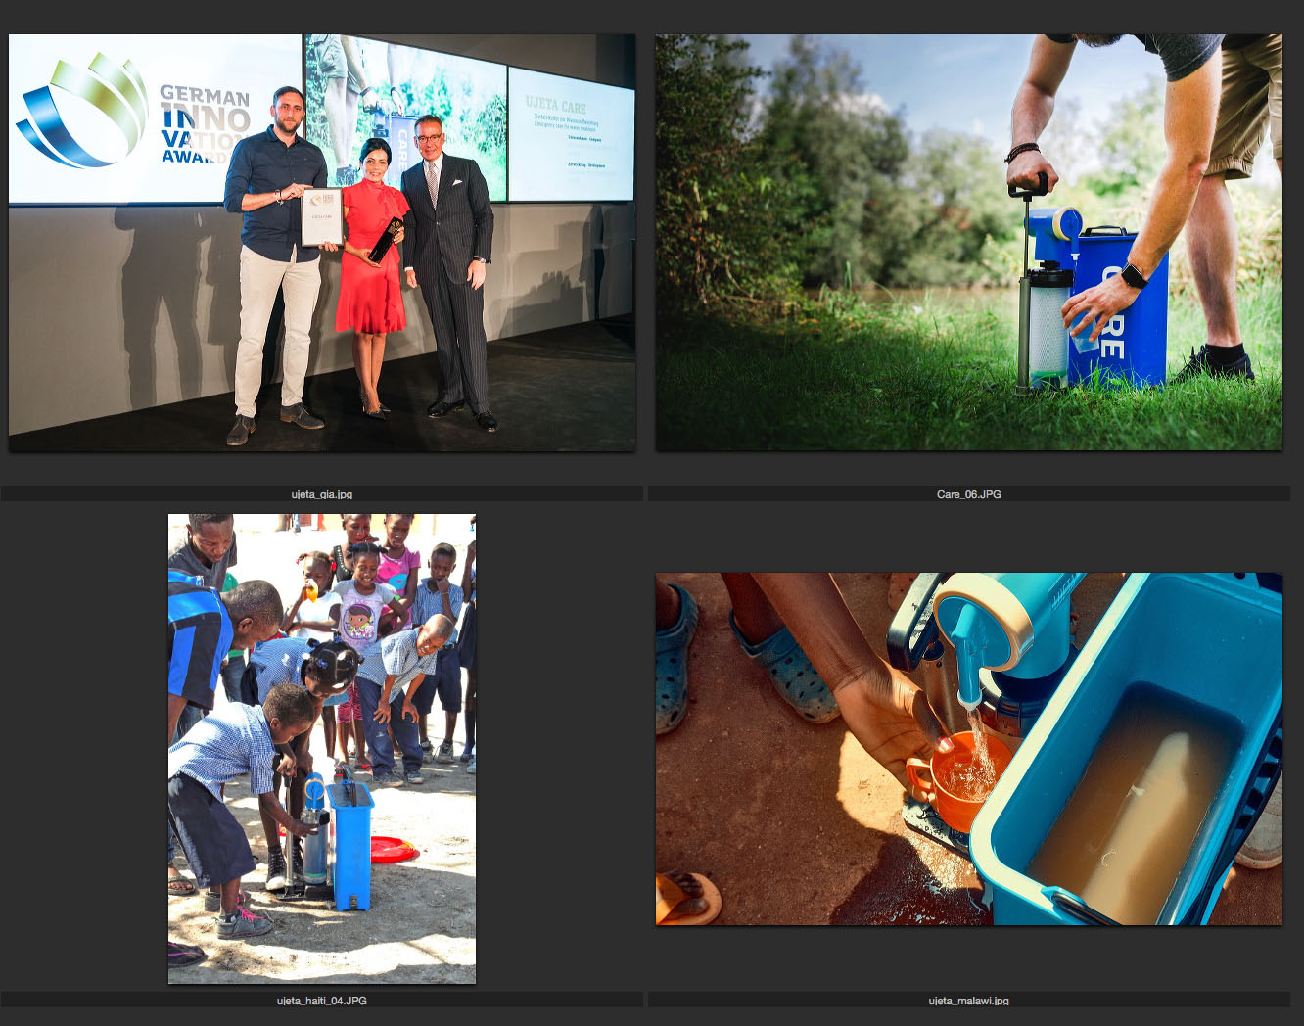

Captions to photos:
ujeta_gia.jpg
Gold for the Ujeta Care: At the prize-giving ceremony for the German Innovation Award in Berlin, Schneider Kunststofftechnik representatives – Managing Director Drita Schneider and Peter Kirchner (left) – celebrate with Andreij Kupetz, General Manager of the German Design Council. Photo: Martin Diepold/Rat für Formgebung

care_06.jpg
The Ujeta Care water filter is also an ideal companion for outdoor adventurers, because it can treat water from rivers and lakes. Photo: Ujeta

ujeta_haiti_04.jpg
That's delicious: these students in Haiti are drinking treated water Photo: Ujeta

ujeta_malawi.jpg
In Malawi in south-east Africa, Ujeta Care filter systems are once again making fresh drinking water from contaminated water. Photo: Ujeta

